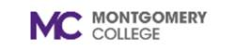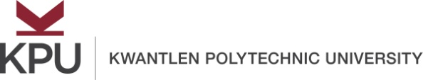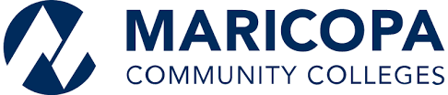

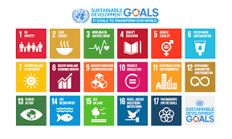

United Nations Sustainable Development Goals
Open Pedagogy Faculty Fellowship Application Form
Summer 2020

Instructions: Fill out this application form and obtain signatures from your chair and dean. Be sure to read the fellowship description for requirements. Submit the completed application package to Dr. Michael Mills (Michael.Mills@montgomerycollege.edu) by midnight on March 30, 2020.
Faculty name and email/telephone extension:
Team Members | Discipline(s) | Proposed Course(s) | Proposed SDG

Please answer the following questions:
Question 1: In one paragraph, describe how open pedagogy might benefit your students in your proposed course(s).

Question 2: In one paragraph, describe how open pedagogy might benefit your discipline.

Question 3: Describe other reasons why you would be interested in becoming a UN SDG Open Pedagogy Faculty Fellow.

Dean Signature of Support: ________________________________
Chair Signature of Support: ________________________________

Please note that if selected, you may be partnered with a faculty member from Kwantlen Polytechnic University in British Columbia (Canada) or Maricopa Community Colleges in Arizona.

