Goal Module User Guide
For the Talent Management System

Table of Contents
Goal Planning Cycle 1
Accessing the Talent Management System 2
Goal Module User Interface 3
Working with your Fiscal Year ‘15 Goal Plan 4
Creating a New Goal 4
Editing a Goal 6
Requesting Approval 6
General Functions 7
Supervisor Functions 8
Assigning a Goal 8
Working with a Direct Reports’ Goals 8

Goal Planning Cycle
An important component of planning and performance management is the employee goal plan. Each fiscal year, employees are expected to develop a plan of goals that will guide their work throughout the year. Ideally, the goal planning process should be seamless – that means that when your performance evaluation is being completed, you and your supervisor should also be discussing and developing a new goal plan for the following year. Your supervisor should provide the initial approval of next year’s plan at the same time they submit this year’s performance evaluation. By default, the TMS places every goal you create into the performance evaluation; however, the TMS also allows you or your supervisor to edit a goal and/or exempt it from the evaluation. Throughout the year you should use the TMS to update goal progress, and edit or modify the goal plan. In order to document the collaboration between you and your supervisor, and to improve productivity, the TMS offers a supervisory approval process for goals. We strongly encourage you to use this process. As you edit the goal plan over the course of the year, a previously approved plan may become “not approved”, depending on the edits you make. We expect supervisors to regularly check in on the goal plans of their reports and actively engage in commenting and re-approving if necessary. In the spring (usually April 1st), a “snapshot” is taken of the names and descriptions of the goals that are marked for inclusion in the performance evaluation. The TMS uses this information to create the pages in the Goal Plan section of the evaluation.
IMPORTANT NOTE FOR SUPERVISORS: In addition to allowing employees to develop goal plans, the TMS also allows supervisors to create goal plans and assign goals to their direct reports. To create the necessary pages for an employee’s performance evaluation, a goal plan must be marked for inclusion in the TMS. Without the goal plan, you and the employee will be unable to submit the evaluation. Therefore, it is your responsibility, as the supervisor, to ensure that your direct reports have goal plans so that the performance evaluation can be completed. If you do not meet the deadline for submitting an employee’s evaluation, you will be ineligible for consideration for an increment and/or bonus. (See HRSTM Performance Management Web page.)

Accessing the Talent Management System
- Navigate to MyMC.
- Click the Employee tab.
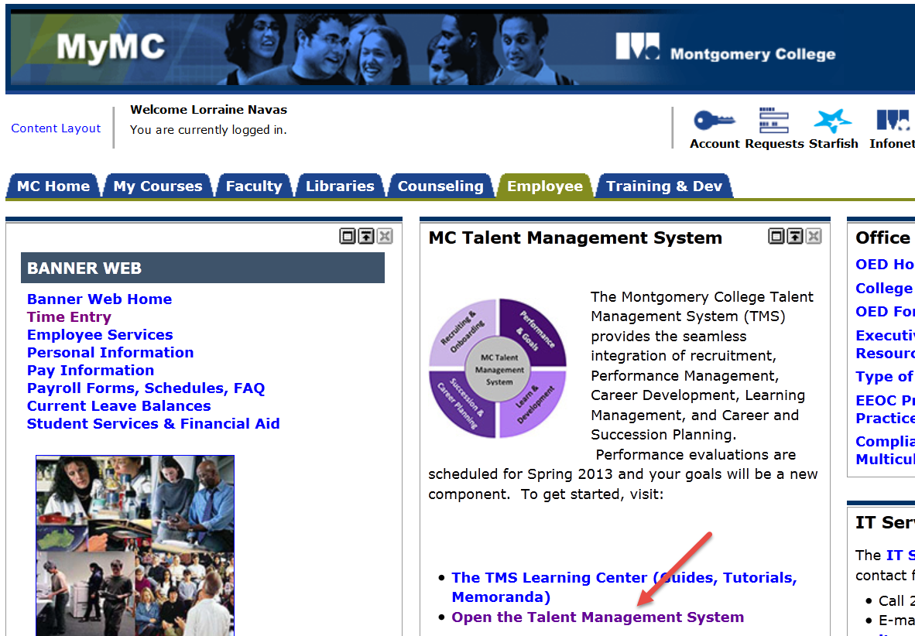
- Click Open the Talent Management System. The Performance homepage is displayed.
- Click the Performance link on the left hand navigation panel. The Performance Management Employee Center page is displayed.
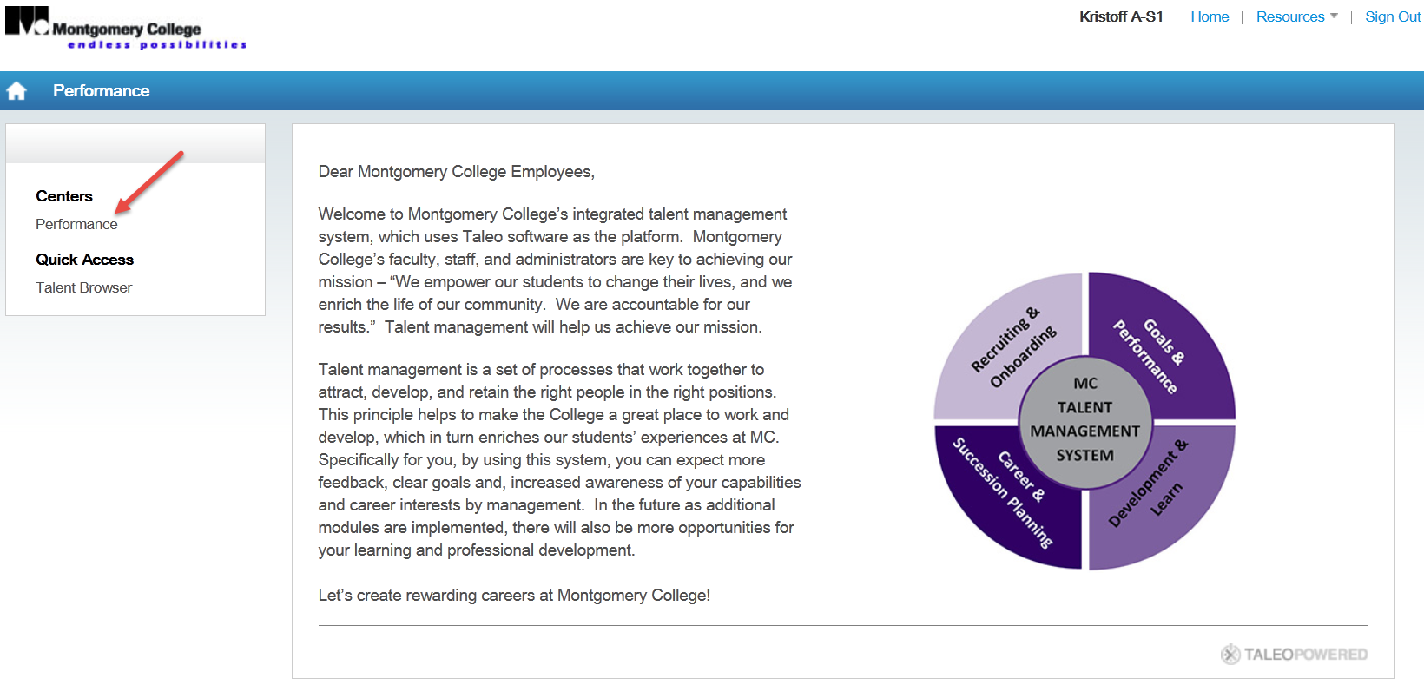
- In the Performance Management Employee Center page, click Goals in the Navigation menu.
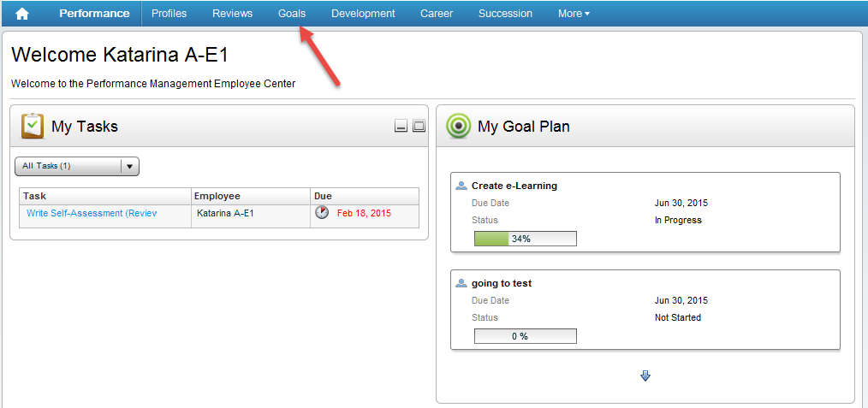
The Goal Module for the current fiscal year will open.

Goal Module User Interface
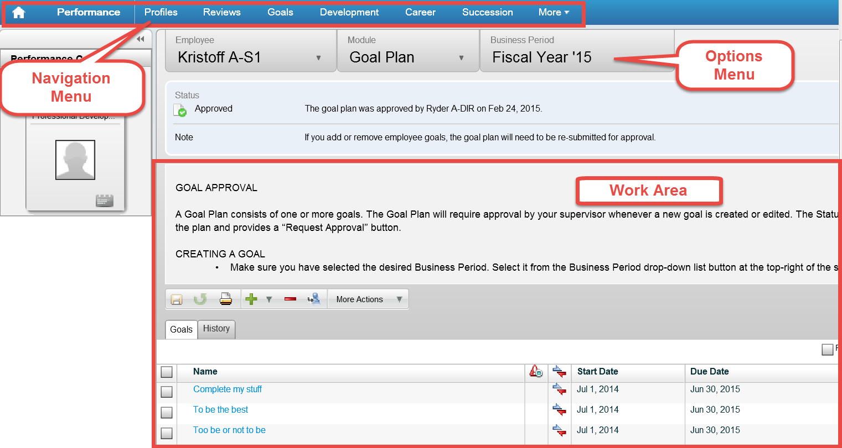

Working with your Goal Plan

Creating a New Goal
- If necessary, click the Create button. The Goal page is displayed.
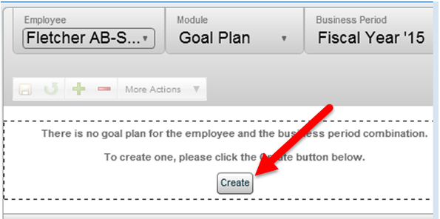
- In the Goal page, click the Add new goal dropdown menu.
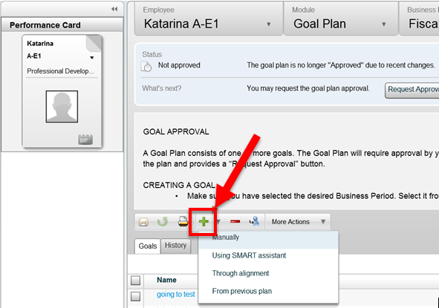
- From the dropdown menu, select Manually. The Create a Goal window is displayed.
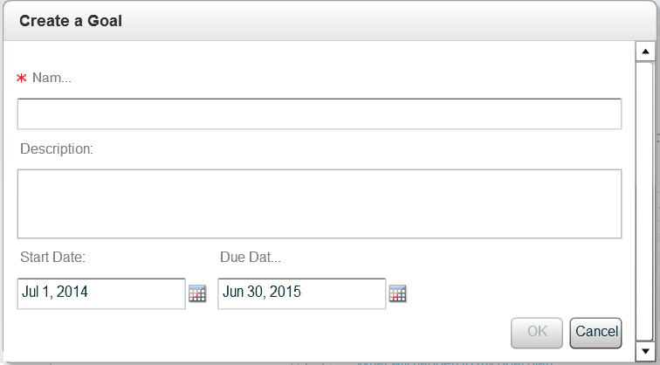
- In the Create a Goal window, do the following:
- Enter a name for your goal in the Name field.
- Enter a description of your goals in the Description box. The Employee Goal screen is displayed.
- Select the start and due dates for your goal
Note: The Due Date defaults to the end of the fiscal year but you can change this to the appropriate due date.
- Click OK.
Note: You creates the “specific” and “timely” attributes of a SMART goal.

- In the Employee Goal screen, do the following:
- By default, the goal is automatically included in the performance evaluation. If you want the goal to be excluded, uncheck the Include in the performance review checkbox.
- In the Measurement section do any or all of the following:
- Use the sliders to track the Progress of your goals.
Use the Measurement Text area to describe how goal progress will be determined.
Note: This creates the “measurable” attributes of a SMART goal.
- Optional: Click the Break Goals into Tasks button to add individual tasks for the goal.
Note: This is one way to create the “achievable” attribute of a SMART goal.
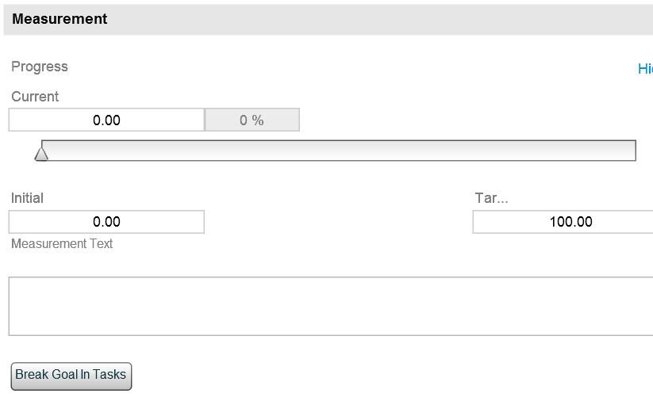
- Click Align to align your goal to one of your supervisor’s goals.
Note: This is how to document the “relevant” attribute of a SMART goal.
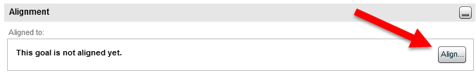
The Alignment window will open:
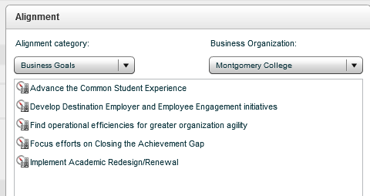
To align your goal to one of your supervisor’s goals, do the following:
- Use the Alignment Category dropdown and select My Supervisor’s Goals
- Hover your mouse over the goals in the goal list to view details about the goal.
- From the goals list, select a goal and click OK.
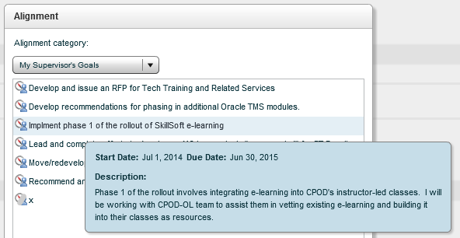
To align your goal to a goal for your College division, do the following:
- Leave the Alignment Category dropdown set at the default, Business Goals
- From the Business Organization dropdown select the division.
- From the goals list for that division, select a goal and click OK.
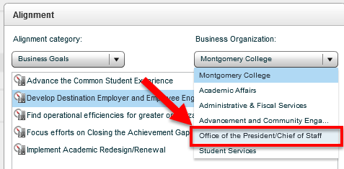
- To Save your goal click the Save the information button to save the goal and continue working, or
Save the information button

- To return to the main goal screen click Go to: Goal Plan.
Go to: Goal Plan button

Editing a Goal
- From the Goal page, select a goal in the Work Area.
- The Employee Goal screen will open. Make any necessary edits.
- If necessary, re-submit your goal plan for approval.(For goal plans that are already approved see the section below titled “Edits Requiring Re-approval”.)

Requesting Approval
Once you have completed your goal plan, you should submit it your supervisor for approval.
To request approval, do the following:
- Click Request Approval. The Confirmation dialog box is displayed.
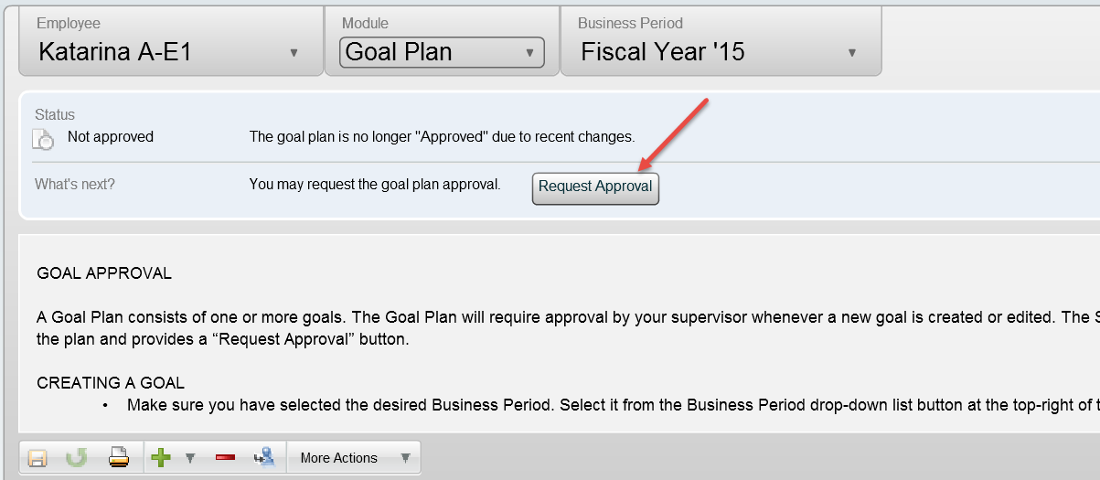
- In the Confirmation dialog box, click OK.
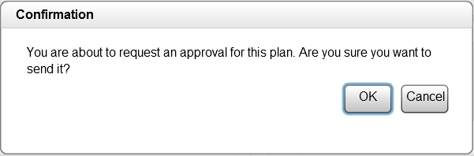

Edits Requiring Re-approval
If your goal plan is already approved and you make any of the following changes, you will need to submit it to your supervisor for re-approval.
- Add or remove a goal. (See item c. below for removing a goal.)
- Change either the start or due date for a goal.
- Change whether or not the goal is included in your performance evaluation.
Additional Functions

General Functions

- Quick Progress Update:
From the main goal screen Use the Progress dropdown to adjust the progress towards your goal.
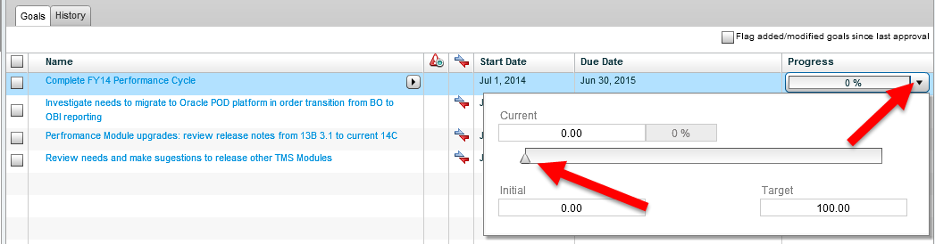

- Flag Goals as Recently Modified
Click the checkbox to flag goals. (This allows your supervisor to see which goals have been changed.)

- Remove Goals from Your Goal Plan
Use Remove this Item icon to remove a selected goal. (You will be prompted to confirm.)

Supervisor Functions

Without the goal plan, you and the employee will be unable to submit the performance evaluation. Therefore, it is your responsibility, as the supervisor, to ensure that your direct reports have goal plans so that the performance evaluation can be completed.

Assigning a Goal
- Create a new goal by following the instructions above.
Note: Your goals and those you assign are listed together on the main goal page. If this goal is to be assigned to one or more direct reports, add their initials to the goal name so that you are able to quickly locate it later.
- After creating it, return to the main goal page and select it by clicking the checkbox next to the name of the goal.
- Click the Assign the selected goal to my direct reports icon. The Goal Assignment dialog box is displayed.
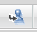 Assign the selected goal to my direct reports icon
- Click the Selected Employees icon. The People Selector dialog box is displayed.
Selected Employees icon
- Click the checkbox next to the name of the employee or employees you want to assign the goal to.
- Click the Add to Selection icon.
Add to Selection icon
- Click Select.
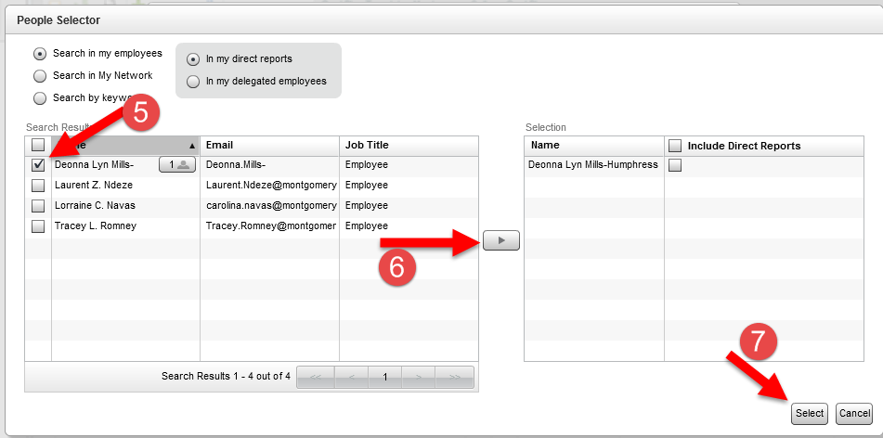
- In the Goal Assignment dialog box, click OK and click OK again to confirm.

Working with a Direct Reports’ Goals
- From the Goal page, click the Employee dropdown.
- Select the employee whose goals you want to work with.
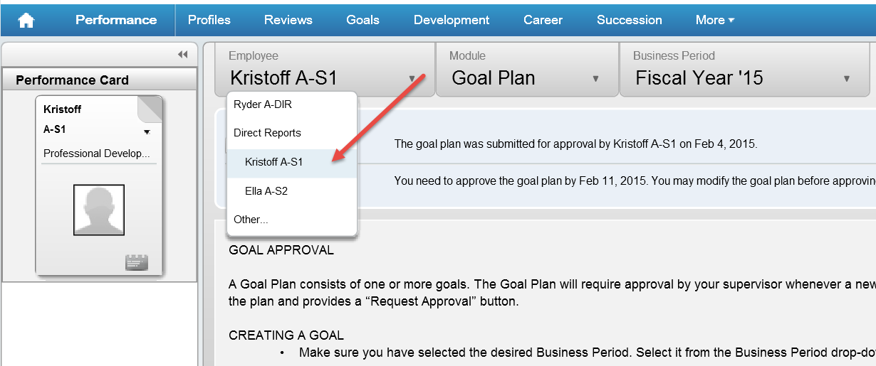
- Do any or all of the following:
- If necessary, click the name of the goal to edit it.
- Add new goal - Click the Add new goal icon to add a goal to the goal plan.
Add new goal icon
- Remove the item - Select the checkbox of a goal and click the Remove the item icon to remove the goal.
Remove the item icon
- Approve - Click Approve to approve the goal plan.
- Reject - Click Reject to send the goal back to your direct report.
Note: Enter comments in the dialog box and click OK.
